**CSS ASSIGNMENT 1.1**

You have to write HTML, CSS for the below design

Color code:

* Orange: #FF7F00
* Blue: #0000FF
* Purple: #80007E
* Green:#D8DA3D

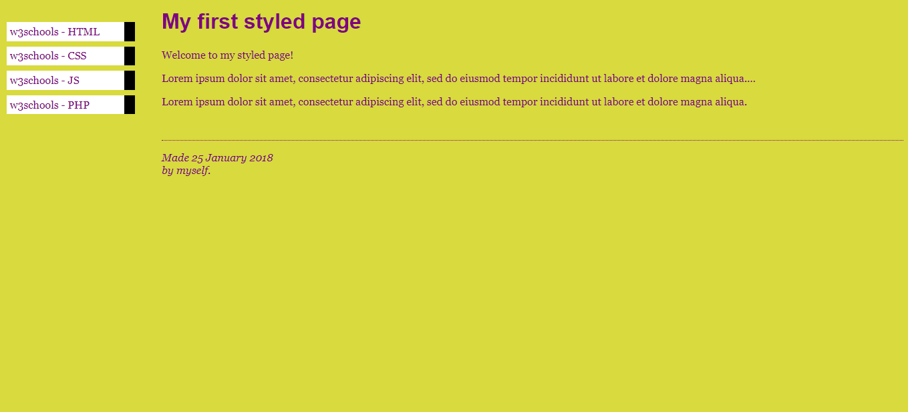

**Execution Criteria for the Assessment**

* 1. Adding proper comments - 1 **Points**
* 2. Formatting of CSS Structure - 2 **Points**
* 3. Use shorthand properties- 2 **Points**
* 4. Desire Output as an Image. - **5 Points**

**Points:**10

**Submitting:**a website url

**CSS ASSIGNMENT 1.2**

You have to write HTML, CSS for the below design

Color code:

* Orange: #FF7F00
* Blue: #0000FF
* Purple: #80007E
* Green:#D8DA3D

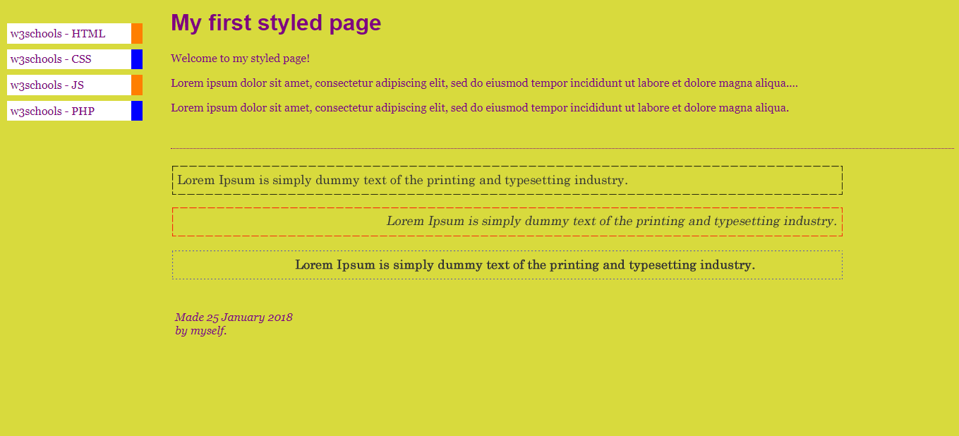

**Execution Criteria for the Assessment**

* 1. Adding proper comments - 1 **Points**
* 2. Formatting of CSS Structure - 2 **Points**
* 3. Use shorthand properties- 2 **Points**
* 4. Desire Output as an Image. - **5 Points**

**Points:**10

**Submitting:**a website url

**CSS ASSIGNMENT 2**

You have to write HTML, CSS for the below design.

This section width should be 800px and height would be 500px and the content should be vertically and horizontally centered.

Color code:

* Pink: #FF9999
* Gray: #ECECFB

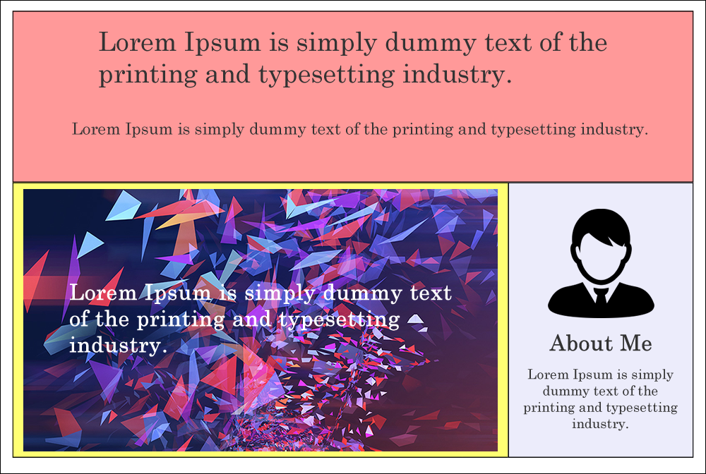

**Execution Criteria for the Assessment**

* 1. Adding proper comments - 1**Points**
* 2. Formatting of CSS Structure - 2**Points**
* 3. Use shorthand properties- 2**Points**
* 4. Desire Output as an Image. - **5 Points**

**Points:**10

**Submitting:**a website url

**CSS ASSIGNMENT 3**

You have to write HTML, CSS for the below design

In the Image 1 section, You have to set the image from the topmost position.

In the Image 2 section, You have to set the image from the bottom most position.

In the Image 3 section, image section size should be 500x300 and you need to display the whole image without cropping/stretching an image.

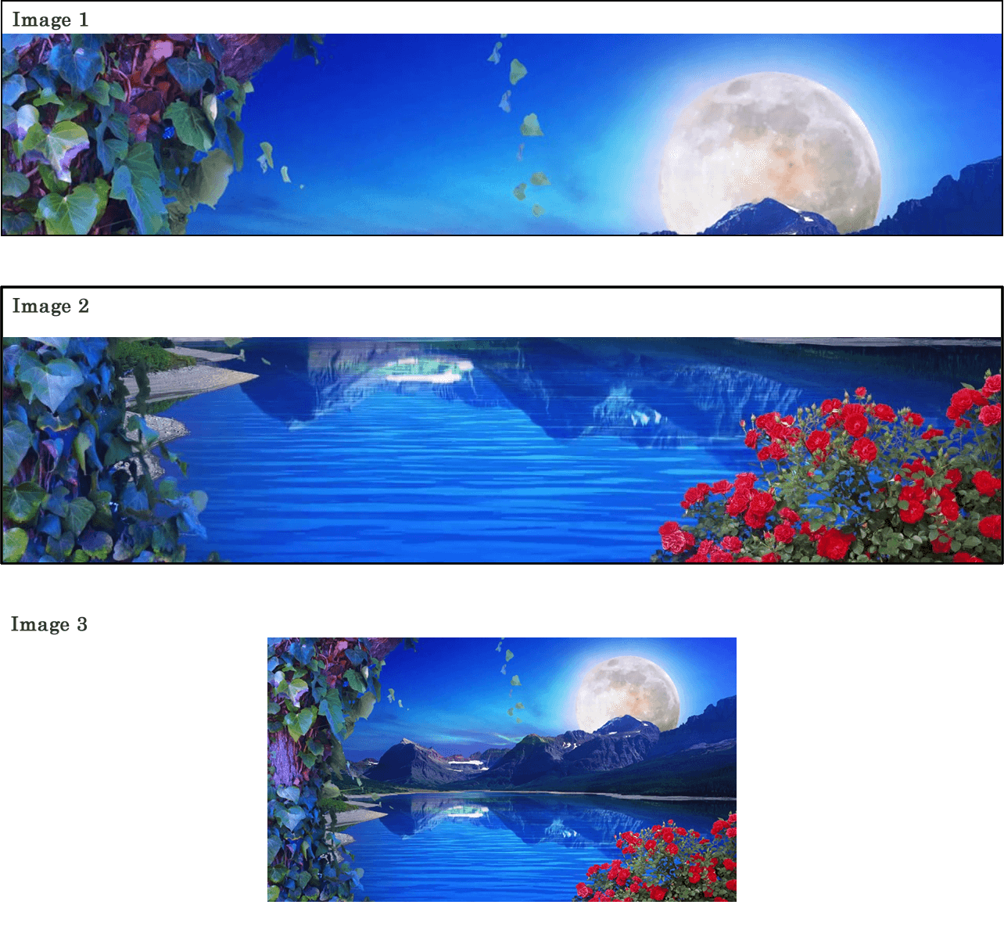

**Execution Criteria for the Assessment**

* 1. Adding proper comments - 1**Points**
* 2. Formatting of CSS Structure  - 2**Points**
* 3. Use shorthand properties- 2**Points**
* 4. Desire Output as an Image. - **5 Points**

**Points:**10

**Submitting:**a website url

Top of Form

Bottom of Form